Sennheiser launches MKH 8030 figure-of-eight RF condenser microphone
“It’s the missing link in the sound designer’s toolbox”

Wedemark, May 2024 – Sennheiser’s long-awaited MKH 8030 RF condenser microphone with figure-of-eight pick-up pattern is available now. The MKH 8030 not only unlocks M-S, double M-S, and Blumlein stereo recording options, but is also a great choice wherever the highest attenuation of neighbouring sound sources is required – be it a PA system whose sound needs to be eliminated or an adjacent instrument that must not be picked up. The sound signature of the MKH 8030 has been carefully engineered to blend in harmoniously with the sound of the existing MKH 8000 series microphones.

The MKH 8030 figure-of-eight RF condenser microphone is extremely compact, with a diameter of 19/21 mm and a length of 93 mm including the XLR module

“We are thrilled to finally launch the MKH 8030, a microphone that the MKH user community has been anticipating for quite a few years,” shares Kai Lange, Product Manager Professional, Wire-bound. “The extremely compact 8030 is ideal for field recording, sports and general broadcasting, theatres, orchestral recordings and studio music.”

The Sennheiser MKH 8000 series and the new MKH 8030 are at home in the most diverse recording situations, from music to field recording and broadcasting (photo credit for the redwood shot: Thomas Rex Beverly). The top right-hand picture shows Simon Charles from Sound in Dubai, making an MS stereo recording using the new MKH 8030. Simon has more than two decades of expertise in sound production, encompassing a diverse range of projects such as short films, features, TV series, documentaries, commercials, and corporate productions (Photo credit: Zeus Mehri)

Sennheiser’s MKH 8000 family of RF condenser microphones
The MKH 8030 joins the MKH 8020 (omni-directional), MKH 8090 (wide cardioid), MKH 8040 (cardioid), MKH 8050 (super-cardioid), MKH 8060 (short shotgun, super-cardioid/lobar) and MKH 8070 (long shotgun, lobar) RF condenser microphones. Also part of the family is the MKH 800 TWIN, a dual-capsule microphone whose pick-up pattern can be seamlessly adjusted at the mixing desk during recording, or even after the actual recording during post-production.

Their special RF condenser principle and the symmetrical capsule design endows MKH 8000 series microphones with a combination of advantages that can only be found in this series: Remarkable sensitivity paired with durability in adverse climatic conditions, wide frequency response, a fully floating, balanced output signal, low self-noise, and a natural, coherent sound image with no off-axis colouration.

These features enable sound recordists and engineers to capture a sound event in its entirety and with all its intricate detail, with wide dynamics, extremely low distortion, and a largely frequency-independent polar pattern. “The MKH 8000 family are tools for creating natural sound of the highest quality and detail,” adds Lange.

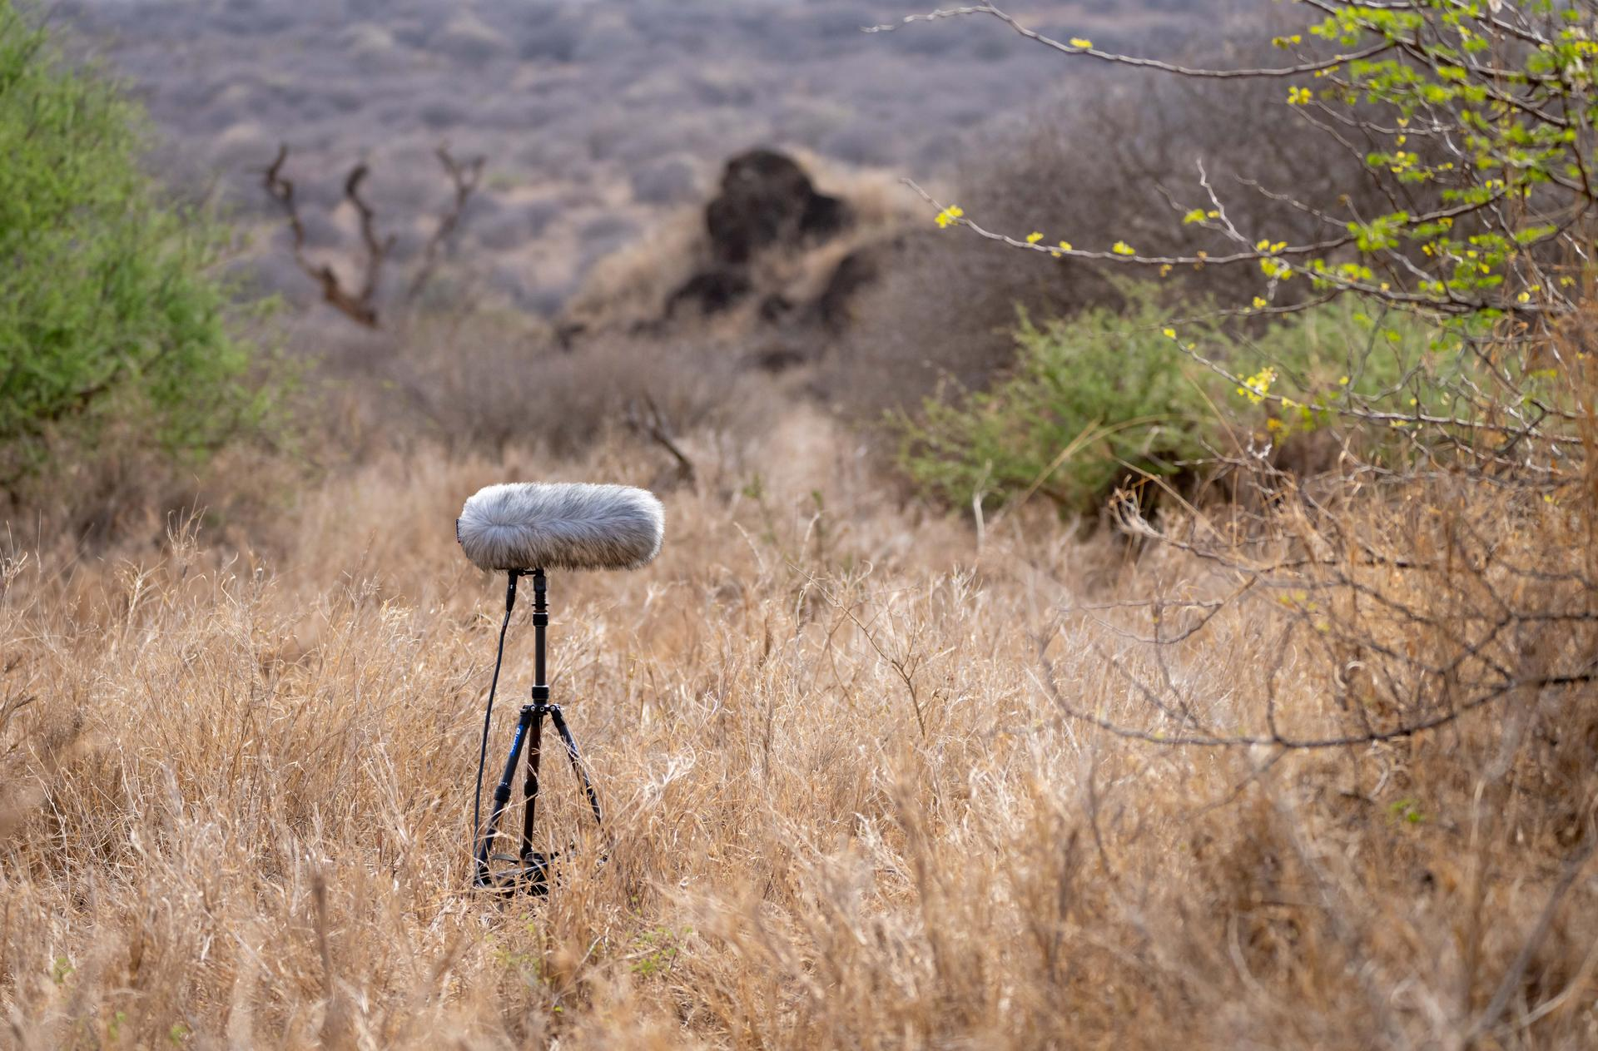 | The MKH 8000 series mics are firm favourites with field recordists  (Picture courtesy of George Vlad)

New accessories for the MKH 8000 series
To accommodate the left/right orientation of the MKH 8030, the MZE extension tubes of the series have been updated and fitted with a rotatable head, while the MZGE 8000 tube connector has been improved, now featuring a more robust design. New in the accessory portfolio is the MZH 8042 gooseneck, which brings the exceptional audio quality of a connected MKH microphone, for example the MKH 8040, to the lectern.

The MKH 8030 is available from May 2024 at EUR 1,499 (MSRP) / USD 1,499 (MAP). Delivery includes an MZW 8030 foam windshield, an MZQ 8000 mic clamp and two Rycote back-to-back clips to create mic pairs.

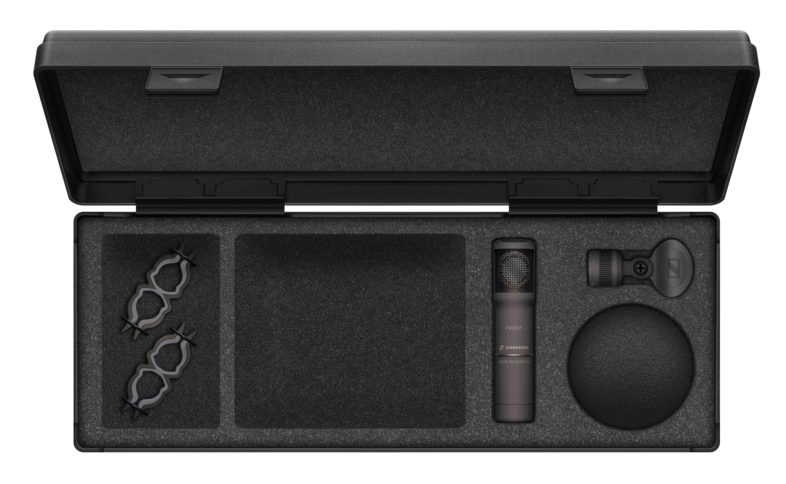 | The MKH 8030 comes with a foam windshield, a mic clamp and two back-to-back clips to create mic pairs

MKH 8030 Technical Data
Microphone principle: RF condenser
Pick-up pattern: figure-of-eight
Frequency response: 30 - 50,000 Hz
Equivalent noise level: 13 dB(A)
Maximum SPL: 139 dB
Dimensions: Ø 19 mm/21 mm, length: 59 mm (93 mm with XLR module)
Weight: approx. 86 g with XLR module

(Ends)

The images accompanying this media release and additional product pictures can be downloaded here.

About the Sennheiser brand
We live and breathe audio. We are driven by the passion to create audio solutions that make a difference. Building the future of audio and bringing remarkable sound experiences to our customers – this is what the Sennheiser brand has represented for more than 75 years. While professional audio solutions such as microphones, meeting solutions, streaming technologies and monitoring systems are part of the business of Sennheiser electronic GmbH & Co. KG, the business with consumer devices such as headphones, soundbars and speech-enhanced hearables is operated by Sonova Holding AG under the license of Sennheiser.

www.sennheiser.com
www.sennheiser-hearing.com

Global Pro Audio Press Contact
Stephanie Schmidt
stephanie.schmidt@sennheiser.com
+49 (5130) 600 – 1275

